WEEK 2

Aim
To design and develop a Static Campus Placement Application for Anil
Neerukonda Institute of Technology & Sciences (ANITS) using HTML5 and CSS3, demonstrating semantic webpage structure, responsive layouts, navigation menus, forms, and attractive styling.

Description:
This experiment involves developing a static Campus Placement Application using only HTML5 and CSS3. The application is designed as a professional institutional placement portal that provides information about the Training and Placement Department, student registration, student login, participating companies, placement information, and contact details.
The application consists of interconnected webpages including Home, About,
Student Registration, Registration Success, Student Login, Companies, and Contact pages. HTML5 semantic elements, hyperlinks, images, lists, tables, forms, HTML5 validation, and iframes are used to structure and organize the website. CSS3 is used to provide responsive layouts, Flexbox, backgrounds, gradients, hover effects, box shadows, border radius, transitions, and other styling features.
The website provides students with an interactive and well-organized interface for accessing campus placement-related information

Program code:
Index.html:
<html>
<head>
<title>Anits-home</title>
<meta charset="UTF-8">
<meta name="description" content="Anits college">
<meta name="author" content="Lasya">
<link rel="stylesheet" href="css/style.css">
</head>

<header>

<img src="images/logo.jpeg">

<div class="title">

<h1>Anil Neerukonda Institute of Technology & Sciences</h1>
<h3><b>Campus Placement Portal</b></h3>

</div>
</header>
<nav>
<a href="index.html">Home</a>
<a href="about.html">About</a>
<a href="registration.html">Register</a>
<a href="login.html">Login</a>
<a href="companies.html">Companies</a>
<a href="contact.html">Contact</a>
</nav>
<div class="hero">
<video loop muted autoplay src="videos\anitsav.mp4"></video>
<div class="text">
<p>printf("Welcome to the Future of Learning!")</p>
</div>
</div>
<marquee direction="left" scrollamount="10">Welcome to Anits Central
Placement Portal</marquee>
<section class="stats">
<div class="box">
<h2>250+</h2>
<p>Recruiters</p>
</div>
<div class="box">
<h2>95%</h2>
<p>Placement Rate</p>
</div>
<div class="box">
<h2>35 LPA</h2>
<p>Highest Package</p>
</div>
<div class="box">
<h2>1200+</h2>
<p>Offers Made</p>
</div>
</section>
<footer>
<p>&copy; 2026 ANITS | Department of Training and Placement</p>
</footer>
</html>

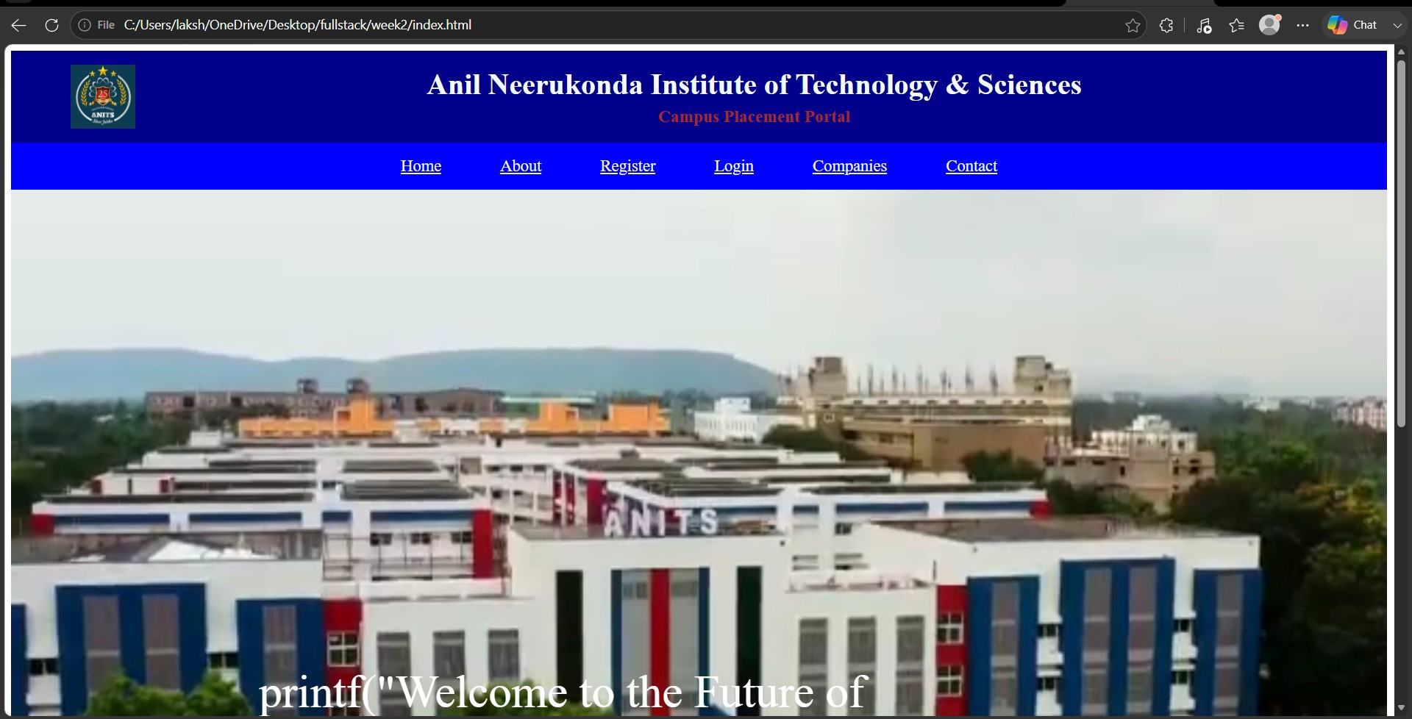
About.html:
<html>
<head>
<title>Anits-About</title>
<meta charset="UTF-8">
<meta name="description" content="Anits college">
<meta name="author" content="Lasya">
<link rel="stylesheet" href="css/style.css">
</head>

<header>

<img src="images/logo.jpeg">

<div class="title">

<h1>Anil Neerukonda Institute of Technology & Sciences</h1>
<h3><b>Campus Placement Portal</b></h3>

</div>
</header>

<nav>
<a href="index.html">Home</a>
<a href="about.html">About</a>
<a href="registration.html">Register</a>
<a href="login.html">Login</a>
<a href="companies.html">Companies</a>
<a href="contact.html">Contact</a>
</nav>
<div class="box1">
<div class="heading">
<h2>About the Training & Placement Department</h2>
</div>

<p><b>Anil Neerukonda Institue of Technology & Sciences (ANITS)</b> has a dedicated <b>Training & Placement Department</b> led by
<b>Prof.P.Padmaja</b>and supported by <b>18 Faculty Coordinators.</b>The
Department
is committed to maximising student placenmets in both software and core engineering sectors through continuous skill development and industry engagement</p>
<p>ANITS provides comprhensive Campus Recruitment Training (CRT) covering <b>Quantitative Aptitude,Logical Reasoning,Verbal
Reasoning,English Communication,Group Discussions,</b> and <b>Interview Skills.</b> These programs are conducted
by experienced in-house trainers to prepare the students for campus recruitment.
</p>
<p>Recruiter feedback and alumni performance are regularly analysed to improve training strategies and align them with industry requirements. The institute offers excellent placement infrastructure, including a <b>400-seat air
conditioned auditorium,computer laboratories and examination halls accomodating over 500 students </b>, and <b>well-equipped interview rooms</b> for smooth recruitment processes.
</p>
<p>Through dedicated efforts, continuous improvement, and strong collaboration with industry, ANITS has consistently achieved an excellent placement record.
The institute is recognized as one of the <b>Top Ten Most Preferred Private
Engineering Colleges in Andhra Pradesh</b> by APSCHE among more than
<b>700 engineering institutions.</b></p>
<div style="color: darkblue;">
<h2>Our Department Focuses On </h2>

</div>
<ul>
<li>Identifying employment opportunities for fresh engineering graduates.</li>
<li>Building strong industry–academia partnerships.</li>
<li>Providing comprehensive campus recruitment training programs.</li>
<li>Organizing industry expert lectures, workshops, and interactive sessions.</li>
<li>Promoting innovation and entrepreneurship development.</li>
<li>Facilitating internships, industrial visits, and technical collaborations.</li> </ul>

</div>
<div class="f1">
<footer>
<p>&copy; 2026 ANITS | Department of Training and Placement</p>
</footer>
</div>
</html>

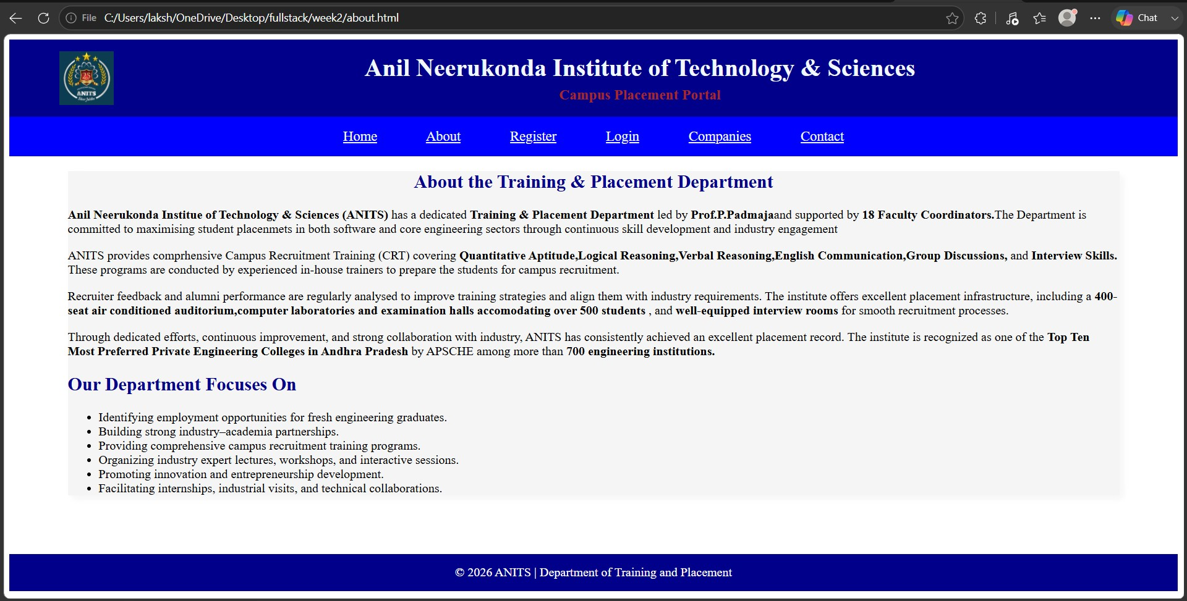
Companies.html:
<html>
<head>
<title>Anits-companies</title>
<meta charset="UTF-8">
<meta name="description" content="Anits college">
<meta name="author" content="Lasya">
<link rel="stylesheet" href="css/style.css">
</head>

<header>

<img src="images/logo.jpeg">

<div class="title">

<h1>Anil Neerukonda Institute of Technology & Sciences</h1>
<h3><b>Campus Placement Portal</b></h3>

</div>
</header>
<nav>
<a href="index.html">Home</a>
<a href="about.html">About</a>
<a href="registration.html">Register</a>
<a href="login.html">Login</a>
<a href="companies.html">Companies</a>
<a href="contact.html">Contact</a>
</nav>
<h3>Recruiting Companies</h3>

<table class="tb" border="1">
<thead>
<td>Company</td>
<td>Role</td>
<td>Package</td>
</thead>
<tr>
<td>MANG Companies</td>
<td>SDE</td>
<td>Min 40 LPA</td>
</tr>
<tr>
<td>TCS</td>
<td>Software Engineer</td>
<td>7 LPA</td>
</tr>
<tr>
<td>Infosys</td>
<td>System Engineer</td>
<td>6.5 LPA</td>
</tr>

<tr>
<td>Accenture</td>
<td>Associate</td>
<td>6 LPA</td>
</tr>

<tr>
<td>Cognizant</td>
<td>Programmer Analyst</td>
<td>6 LPA</td>
</tr>

</table>

<div class="placement-highlights">

<div class="placement-card">
<h2>1095+</h2>
<p>JOB OFFERS</p>
</div>

<div class="placement-card">
<h2>12 LPA</h2>
<p>HIGHEST PACKAGE</p>
</div>
<div class="placement-card">
<h2>5.06 LPA</h2>
<p>AVERAGE PACKAGE</p>
</div>

</div>

<div class="placement-highlights">

<div class="placement-card">
<h2>1143</h2>
<p>JOB OFFERS</p>
</div>

<div class="placement-card">
<h2>48 LPA</h2>
<p>HIGHEST PACKAGE</p>
</div>

<div class="placement-card">
<h2>5.26 LPA</h2>
<p>AVERAGE PACKAGE</p>
</div>

</div>
<div class="f2">
<footer class="f4">
<p>&copy; 2026 ANITS | Department of Training and Placement</p>
</footer>
</div>

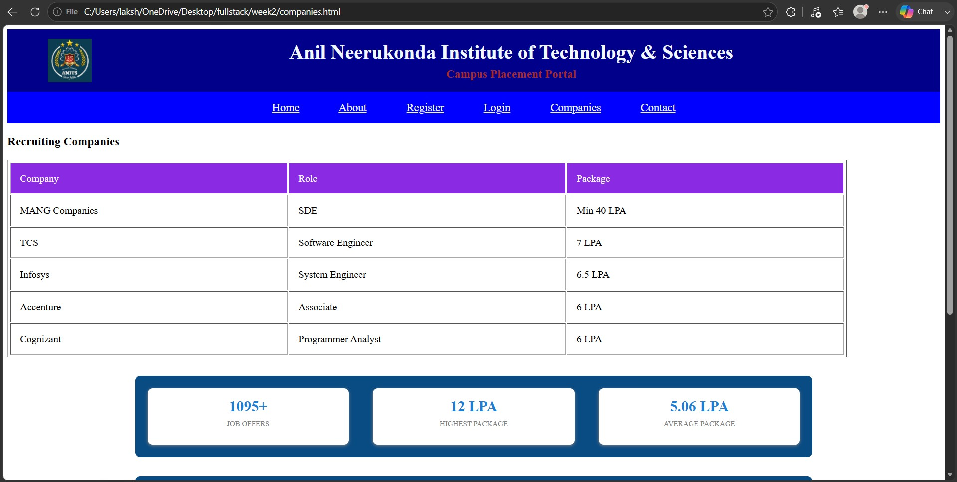
Contact.html:
<html>

<head>
<title>contact-page</title>
<meta charset="UTF-8">
<meta name="description" content="Anits college">
<meta name="author" content="Lasya">
<link rel="stylesheet" href="css/style.css">
</head>
<header>

<img src="images/logo.jpeg">

<div class="title">

<h1>Anil Neerukonda Institute of Technology & Sciences</h1>
<h3><b>Campus Placement Portal</b></h3>

</div>
</header>
<nav>
<a href="index.html">Home</a>
<a href="about.html">About</a>
<a href="registration.html">Register</a>
<a href="login.html">Login</a>
<a href="companies.html">Companies</a>
<a href="contact.html">Contact</a>
</nav>

<h1>Contact Placement Cell</h1>
<p>Email: placements@anits.edu.in</p>
<p>Phone : +91-6898989899</p>

<iframe src="https://www.google.com/maps/embed?pb=!1m18!1m12!1m3!1d3796.2216 751537935!2d83.4229025749605!3d17.921811783059425!2m3!1f0!2f0!3f0!3 m2!1i1024!2i768!4f13.1!3m3!1m2!1s0x3a39581b73ffffff%3A0xd04b9046faa4 565f!2sAnil%20Neerukonda%20Institute%20of%20Technology%20and%20Sc iences%20(ANITS)!5e0!3m2!1sen!2sin!4v1783874194073!5m2!1sen!2sin" width="600" height="450" style="border:0;" allowfullscreen="" loading="lazy" referrerpolicy="strict-origin-when-cross-origin"></iframe>
<div class="f5">
<footer>
<p>&copy; 2026 ANITS | Department of Training and Placement</p>
</footer>
</div>

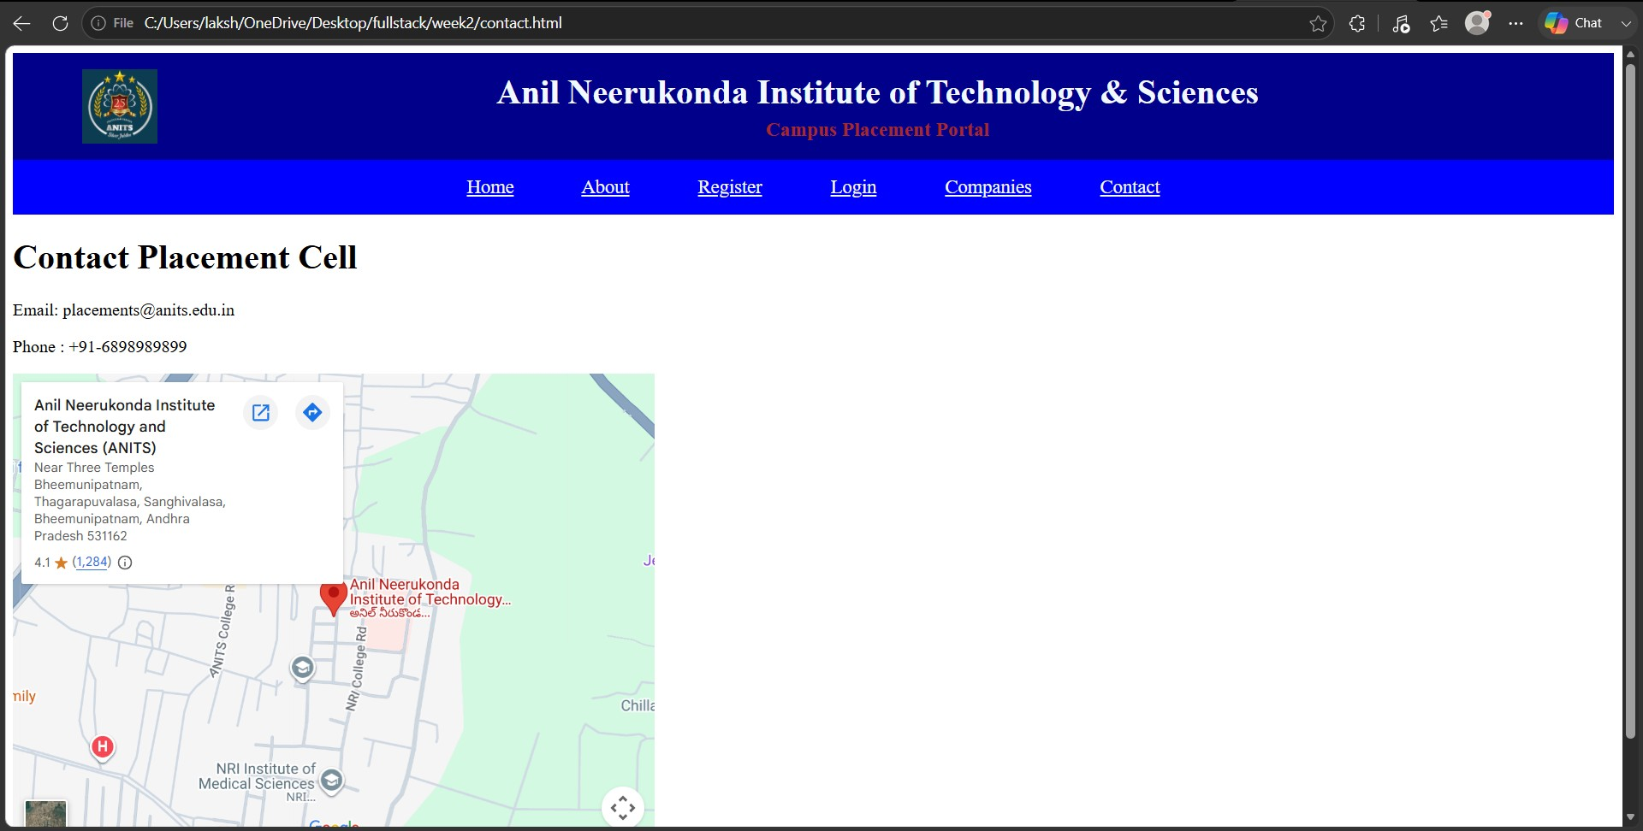
Login.html:
<html>
<head>
<title>Anits-login</title>
<meta charset="UTF-8">
<meta name="description" content="Anits college">
<meta name="author" content="Lasya">
<link rel="stylesheet" href="css/style.css">
</head>

<header>

<img src="images/logo.jpeg">

<div class="title">

<h1>Anil Neerukonda Institute of Technology & Sciences</h1>
<h3><b>Campus Placement Portal</b></h3>

</div>
</header>

<nav>
<a href="index.html">Home</a>
<a href="about.html">About</a>
<a href="registration.html">Register</a>
<a href="login.html">Login</a>
<a href="companies.html">Companies</a>
<a href="contact.html">Contact</a>
</nav>

<main>
<h2>Student Login</h2>

<div class="login-box">

<form>
<label>Username</label>
<input type="text">

<label>Password</label>
<input type="password">

<button>Login</button>
</form>

</div>
</main>

<div class="f2">
<footer>
<p>&copy; 2026 ANITS | Department of Training and Placement</p>
</footer>
</div>

</html>

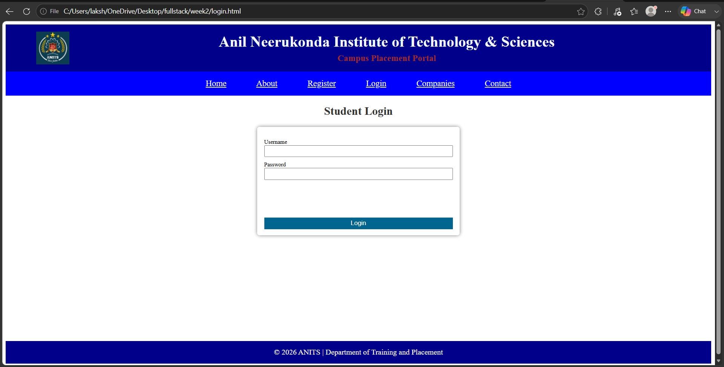
Register.html:
<html>
<head>
<title>Anits-Registration</title>
<meta charset="UTF-8">
<meta name="description" content="Anits college">
<meta name="author" content="Lasya">
<link rel="stylesheet" href="css/style.css">
</head>

<header>

<img src="images/logo.jpeg">

<div class="title">

<h1>Anil Neerukonda Institute of Technology & Sciences</h1>
<h3><b>Campus Placement Portal</b></h3>

</div>
</header>
<nav>
<a href="index.html">Home</a>
<a href="about.html">About</a>
<a href="registration.html">Register</a>
<a href="login.html">Login</a>
<a href="companies.html">Companies</a>
<a href="contact.html">Contact</a>
</nav>
<div align="center">
<h1>Student Registration</h1>
</div>
<form action="success.html">
<fieldset class="box2">
<legend>Personal Information</legend>

<table border="1px" width="100%">
<tr>
<td>Full Name</td>
<td><input type="text" id="name" name="name" placeholder="Enter your name" required></td>
</tr>
<tr>
<td>Password</td>
<td><input type="password" id="password" name="password" placeholder="Enter password" required></td>
</tr>
<tr>
<td>Email Address</td>
<td><input type="email" id="mail" name="mail" placeholder="abc@example.com" required></td>
</tr>
<tr>
<td>Mobile Number</td>
<td><input type="number" id="phn" name="phn" placeholder="9876543210" required></td>
</tr>
<tr>
<td>Age</td>
<td><input type="number" id="age" name="age" required></td>
</tr>
<tr>
<td>Date Of Birth</td>
<td><input type="date" id="date" name="date" required></td>

</tr>
<tr>
<td>Preferred Time</td>
<td><input type="time" id="time" name="time" required></td>
</tr>

<tr>
<td>Registration Date & Time</td>
<td><input type="datetime-local" id="DateTime" name="DateTime" required></td>

</tr>

</table>

</fieldset>
<fieldset class="box2">
<legend>Academic Information</legend>

<table border="1px" width="100%">
<tr>
<td>Department</td>
<td><select id="Department" name="Department" required>
<option>CSE</option>
<option>CSM</option>
<option>CSD</option>
<option>ECE</option>
<option>EEE</option>
<option>MECH</option>
<option>IT</option>
<option>CHEM</option>
</select></td>
</tr>
<tr>
<td>Programming Language</td>
<td><label>
<input type="checkbox" name="pl" value="C" >
C
</label><br>

<label>
<input type="checkbox" name="pl" value="C++">
C++
</label><br>

<label>
<input type="checkbox" name="pl" value="Java">
Java
</label><br>
<label>
<input type="checkbox" name="pl" value="Python">Python
</label>
<br>
</td>
</tr>
<tr>
<td>Gender</td>
<td><input type="radio" name="gender" value="Male">Male<br>
<input type="radio" name="gender" value="Female">Female<br>
<input type="radio" name="gender" value="Other">Other<br>
</td>
</tr>

<tr>
<td>Skills</td>
<td>
<label>
<input type="checkbox" name="skills" value="HTML">HTML
</label>
<br>
<label>
<input type="checkbox" name="skills" value="C">
C
</label><br>

<label>
<input type="checkbox" name="skills" value="C++">
C++
</label><br>

<label>
<input type="checkbox" name="skills" value="Java">
Java
</label><br>
<label>
<input type="checkbox" name="skills" value="Python">Python
</label>
<br>

</td>
</tr>

</table>
</fieldset>

<fieldset class="box2">
<legend>Online Information</legend>

<table border="1px" width="100%">
<tr>
<td>Portfolio Website</td>
<td><input type="text" id="url" name="url" placeholder="https://example.com" required></td>
</tr>
<tr>
<td>Search Course</td>
<td><input type="text" id="cname" name="cname" placeholder="Search Course" required></td>
</tr>

<tr>
<td>Upload Resume</td>
<td>
<input type="file" name="resume" accept=".pdf,.doc,.docx" required>
</td>
</tr>

<tr>
<td>Programming Skill Level</td>
<td>
Beginner
<input type="range" name="skill" min="0" max="10" value="5" required>
Expert
</td>
</tr>

<tr>
<td>Address</td>
<td><input type="text" id="home_address" name="home_address" placeholder="Enter your address" required></td>

</tr>

</table>
</fieldset>
<fieldset class="box2">
<legend>Declaration</legend>

<input type="checkbox" name="agree" value="agree" required><br>
I hereby declare that the information provided above is true and correct.

</fieldset>

<div class="register-buttons">
<button type="submit" class="butn">Register</button>
<button type="reset" class="butn">Reset</button>
</div>

</form>

<div class="f1">
<footer>
<p>&copy; 2026 ANITS | Department of Training and Placement</p>
</footer>
</div>

</html>

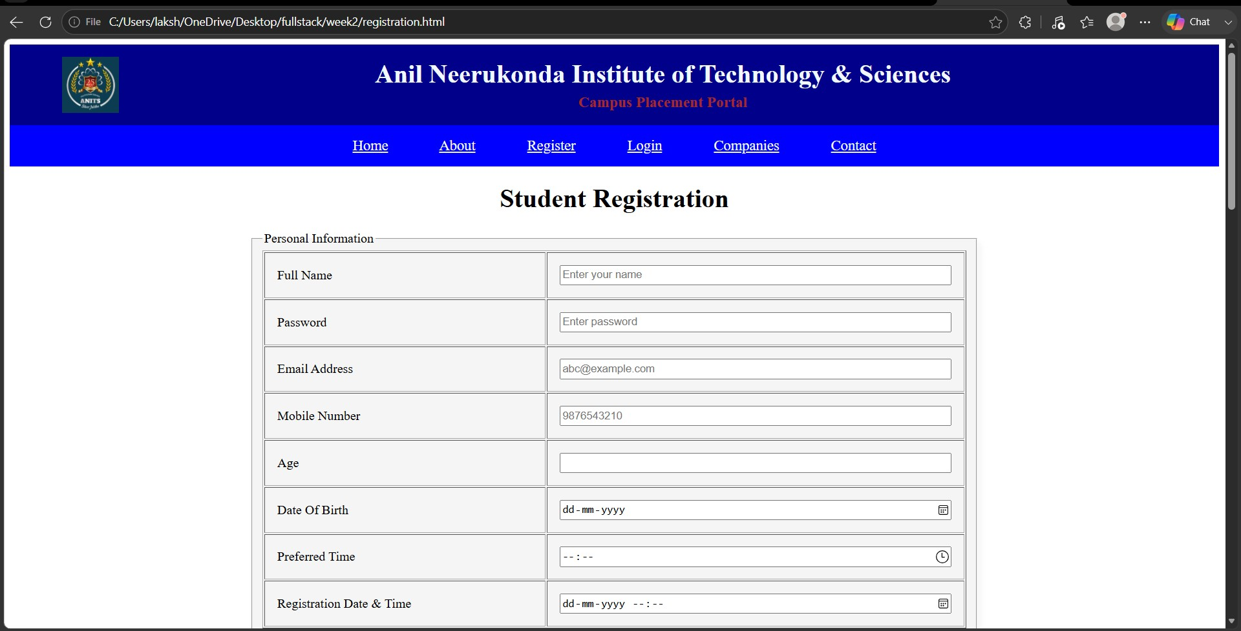
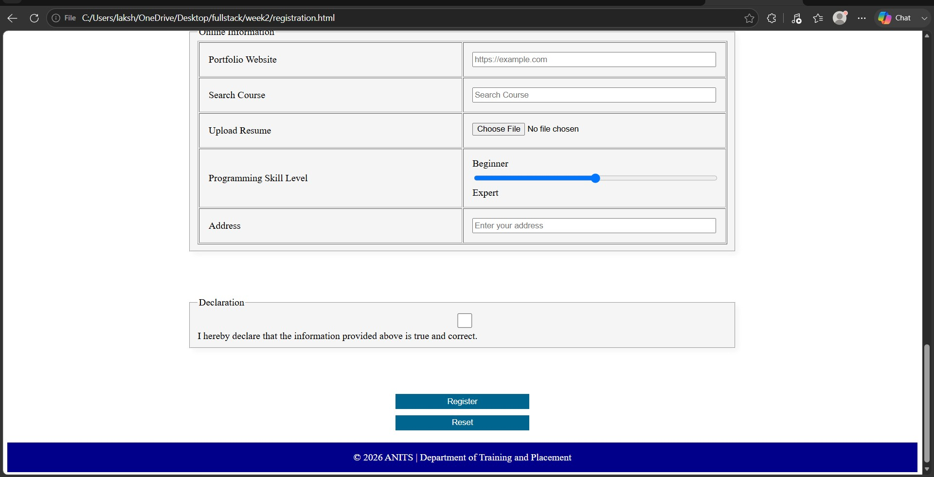
Success.html:
<html>

<head>
<title>Success-page</title>
<meta charset="UTF-8">
<meta name="description" content="Anits college">
<meta name="author" content="Lasya">
<link rel="stylesheet" href="css/style.css">
</head>

<header>

<img src="images/logo.jpeg">

<div class="title">

<h1>Anil Neerukonda Institute of Technology & Sciences</h1>
<h3><b>Campus Placement Portal</b></h3>

</div>
</header>
<nav>
<a href="index.html">Home</a>
<a href="about.html">About</a>
<a href="registration.html">Register</a>
<a href="login.html">Login</a>
<a href="companies.html">Companies</a>
<a href="contact.html">Contact</a>
</nav>
<div class="box3">
<h1 style="color: green;" align="center">Registration
Successful!</h1><br>
<h2 style="color: darkblue;" align="center">Welcome to ANITS Central
Placement Portal</h2>
<p><b>Congratulations! Your registration has been completed successfully. Your profile has been submitted to the Training & Placement Department</b></p>

<div class="Notice">
<h3><b>Important Notice</b></h3>
<ul>
<li>Please contact the Training & Placement Office regularly for updates.</li>
<li>Stay informed about the latest MAANG Companies Recruitment Proecess.</li>
<li>Check your registered Email ID and Placemenr Portal for announcements.</li>
<li>Keep your Resume,Academic Documents, and ID Card ready before every recruitment process.</li>
</ul>
</div>
</div>
<div class="f2">
<footer>
<p>&copy; 2026 ANITS | Department of Training and Placement</p>
</footer>
</div>

</html>

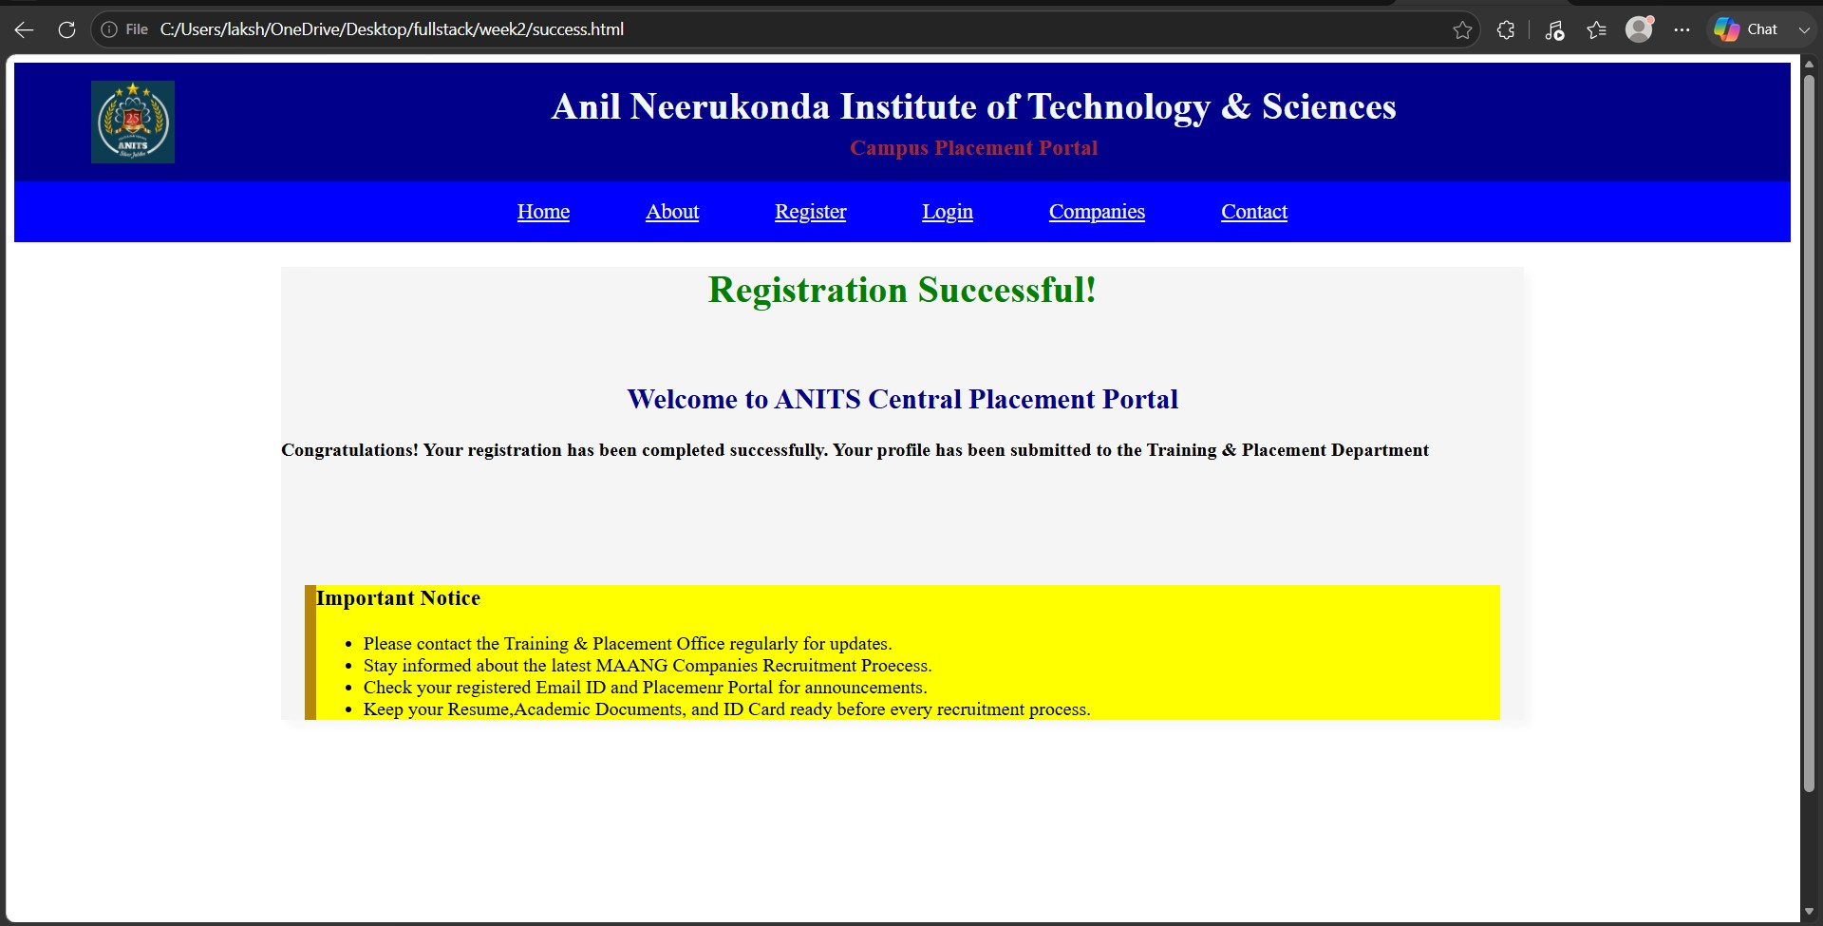
Style.css: header{ background-color: darkblue; display: flex; align-items: center; padding: 15px;

}

header img{ width: 70px; height: 70px;

margin-left: 50px;
}

.title{ flex: 1; text-align: center; } .title h1{ color: aliceblue; margin: 0; }
.title h3{
color: brown; margin: 5px 0 0; } nav{ background-color: blue; text-align: center; padding: 15px; } nav a{ color: aliceblue; margin: 30px; font-size: 18px;
}

.hero{ position: relative;
}

.hero video{ width: 100%;
}

.text{ position: absolute; color: white;

top: 70%; left: 40%;

transform: translate(-50%,-50%); font-size: 50px;
}

marquee{ background-color: darkblue; color: white; font-size: 18px; font-weight: 100; padding-bottom: 10px;
}

.stats{ display: flex; justify-content: space-evenly; margin: 30px;
}

.box{ box-shadow: 5px 5px 10px gray; width: 200px; padding: 20px;
background-color: lightblue; border-radius: 10px;
}

.box h2{ color: darkblue;
}

.box p{ font-size: 18px;
}

footer{ background-color: darkblue; color: white; text-align: center; padding: 10px;
}

footer p{ margin: 5px;
}

.heading{ color: darkblue;
}
.f1{ padding-bottom: 0%;
}
.box1{

box-shadow: 5px 5px 10px whitesmoke;

margin-left: 5%; margin-right: 5%; margin-bottom: 5%; background-color: whitesmoke;

}

.box2{

box-shadow: 5px 5px 10px whitesmoke;

margin-left: 20%; margin-right: 20%; margin-bottom: 5%; background-color: whitesmoke;

}

td{ padding:15px; width:100px;
}

.register-buttons{ width: 220px; margin: 20px auto;
}

.register-buttons .butn{ display: block; width: 100%; margin: 10px 0;
}

.Notice{ margin-top: 10%; border-left-color: darkgoldenrod ; border-left-width: 10px; border-left-style: solid ; background-color: yellow; margin-left: 20px; margin-right: 20px; margin-bottom: 10%;
}
.box3{

box-shadow: 5px 5px 10px whitesmoke;

margin-left: 15%; margin-right: 15%; margin-bottom: 0%; background-color: whitesmoke;

}

main h2 {
text-align: center; color: #333;
}

.login-box { width: 400px; background-color: white; height: 200px; margin: 20px auto; padding: 15px; border-radius: 5px; box-shadow: 0px 0px 8px gray;
}

label { display: block; font-size: 12px; margin-top: 10px;
}

input { width: 100%; height: 25px; box-sizing: border-box;
}

button { width: 100%; margin-top: 20%;

height: 25px;

background-color: #00658f; color: white;

border: none;
} .f2{ margin-top: 15%;
}

.tb{ height: 10px; width:90%; padding: 2px;

} .tb thead{ background-color: blueviolet; color: white;
}

.placement-highlights{ width:70%; margin:30px auto; display:flex; justify-content:space-between; background:#0b4b83; padding:20px; border-radius:8px;
}

.placement-card{ width:28%; background:white; text-align:center; padding:15px; border-radius:8px; box-shadow:0 2px 5px gray;
}

.placement-card h2{ color:#1f7dd4; margin:0;
}

.placement-card p{ margin-top:8px; font-size:12px; color:gray;
}

.f4{ margin-top: 10%; } .f5{ height: 0px;
}

Result:
The Static Campus Placement Application for ANITS was successfully designed and developed using HTML5 and CSS3. The application includes interconnected webpages for Home, About, Student Registration, Registration Success, Student Login, Companies, and Contact. The project demonstrates semantic HTML elements, navigation, forms, tables, responsive design, and CSS styling to create a professional static placement portal.

